TASK 13:

* Create a Virtual Machine.
* Create an Alert rule for VM CPU percentage using Azure Monitor.
* Condition: CPU more than 80%
* Action: Send email.

Steps to perform above task:

Step 1: Create Virtual machine by logging inside Azure portal.

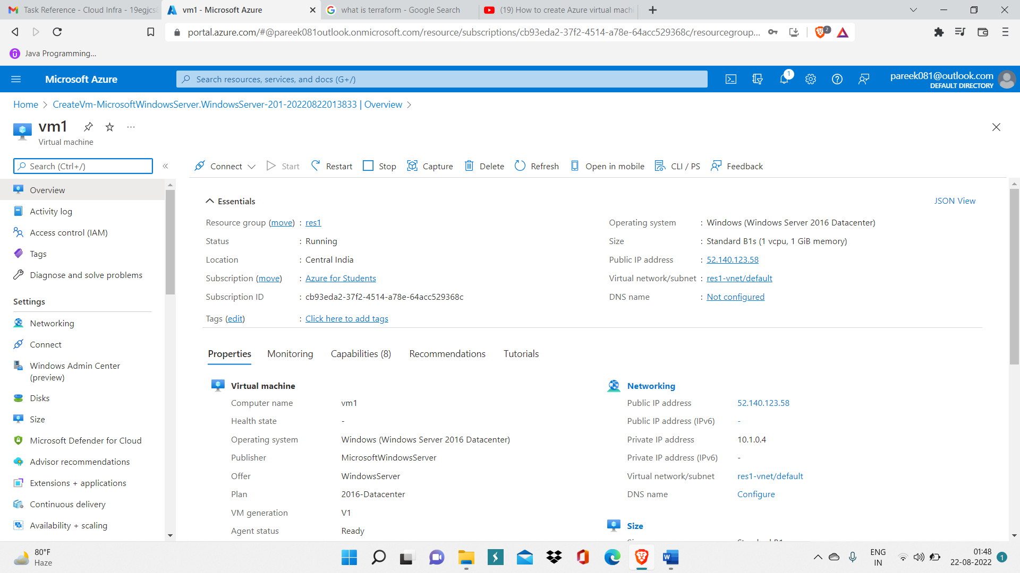

Step 2: Now search on dashboard, Monitors and then click on it, and then you will be redirected to azure monitor service.

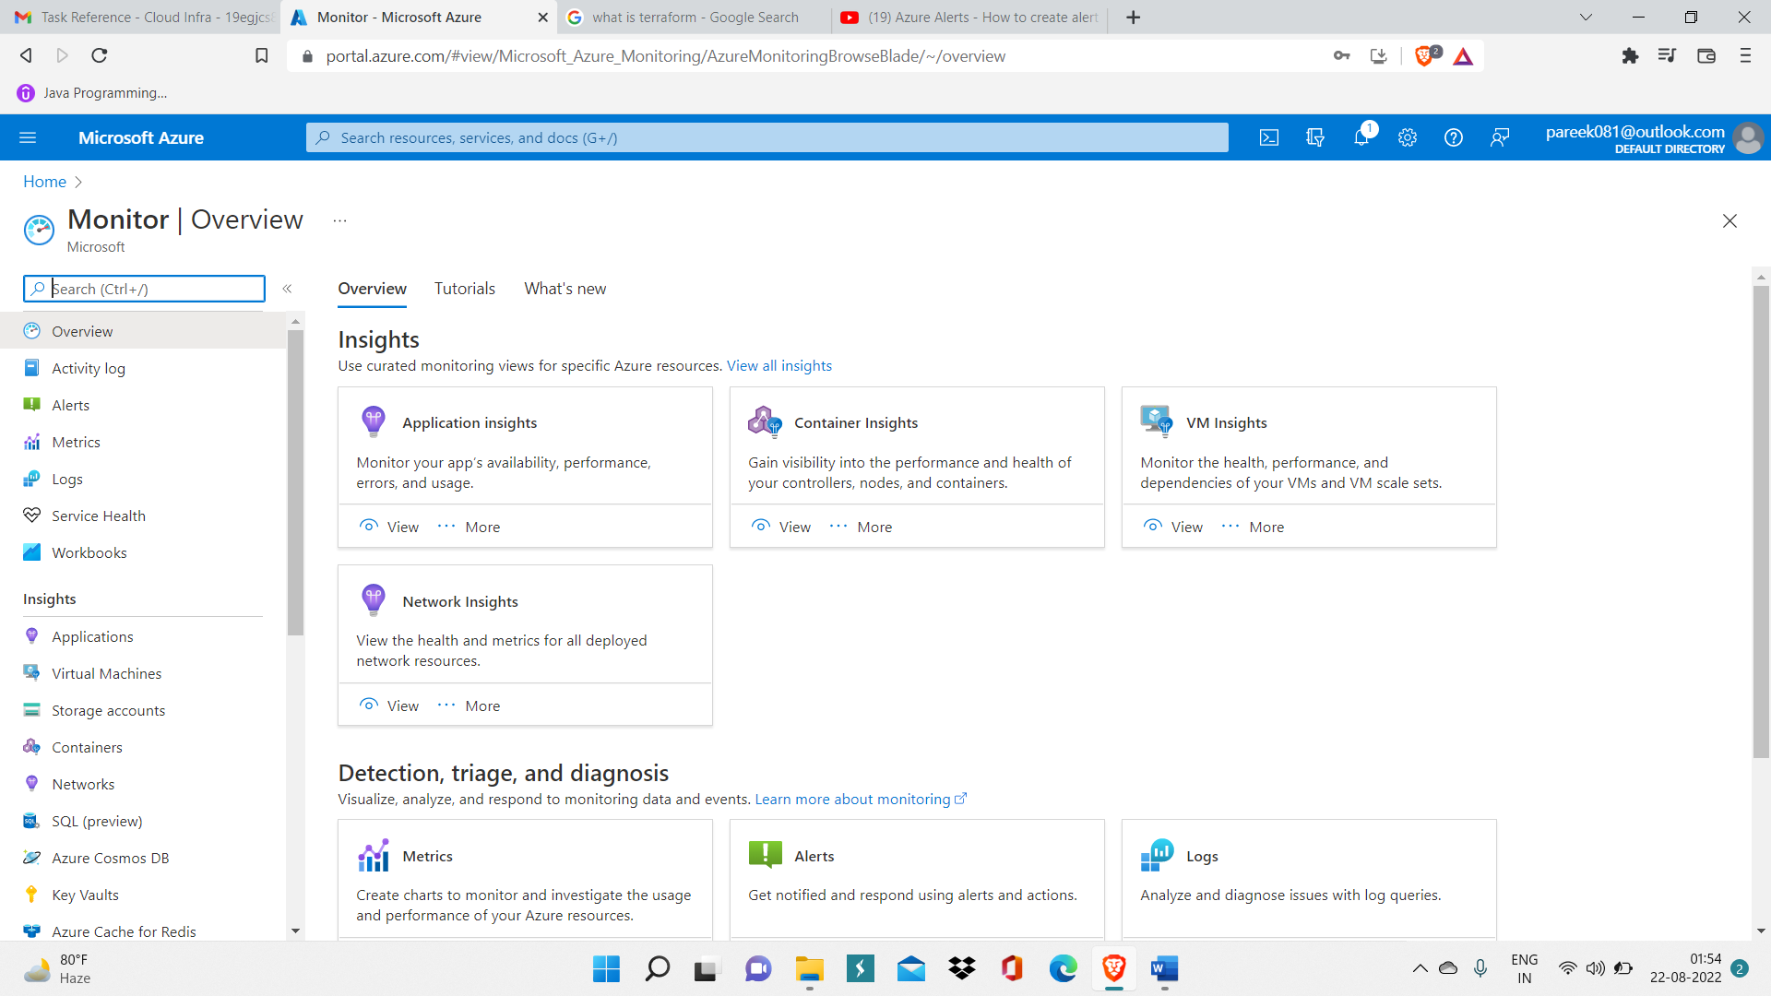

Step 3: Now go inside Alerts and click on ‘Create alert rule’.

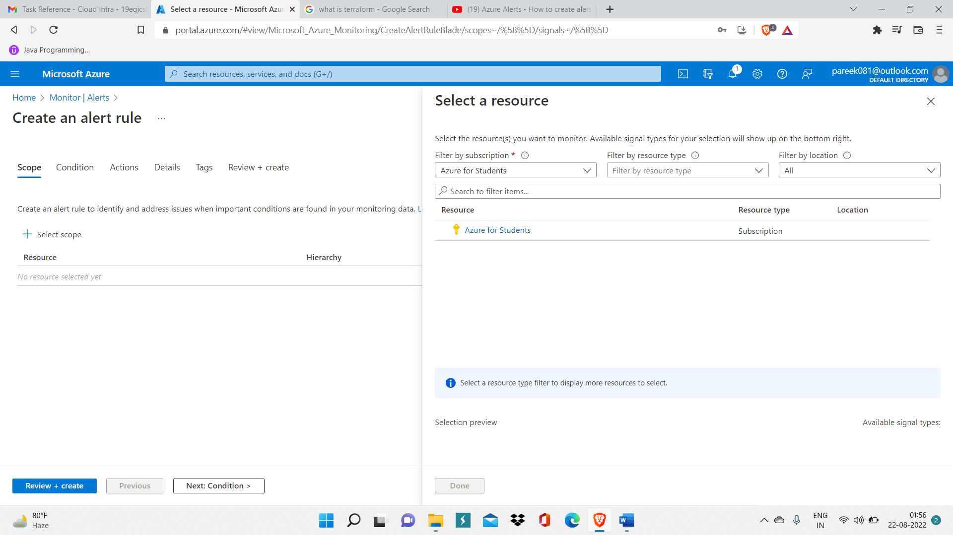

Step 4: Now filter out the resource group (res1) and VM (vm1) and then click on done.

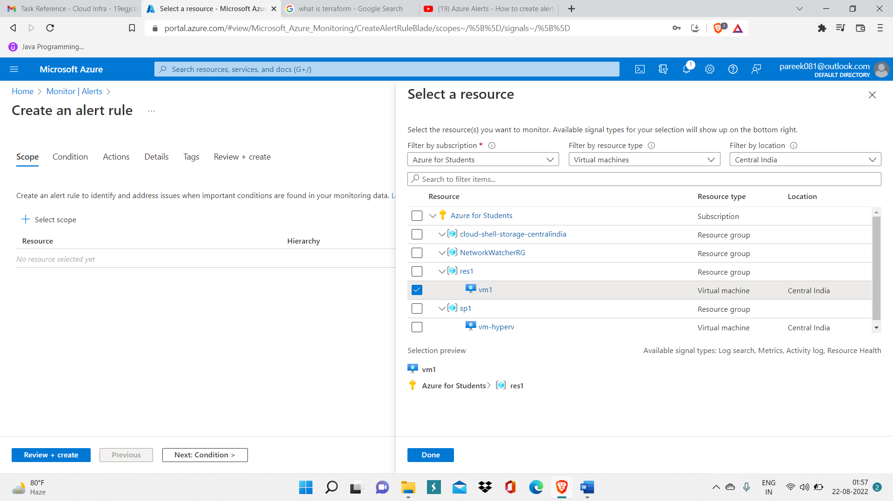

Step 5: Now specify condition: ‘CPU more than 80%’ by selecting metric ‘CPU percentage’ and specifying threshold value 80%, then, click on Add.

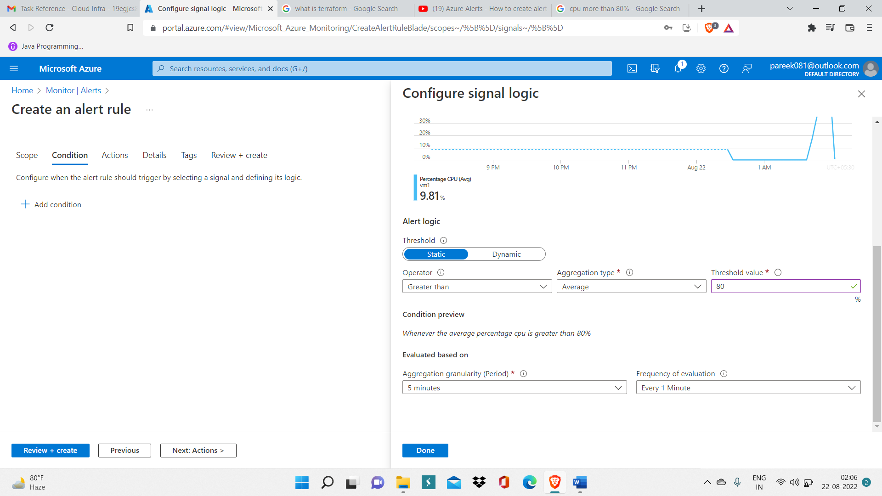

Step 6: Now, create action group and specify action name and other necessary details like displayed name of action.

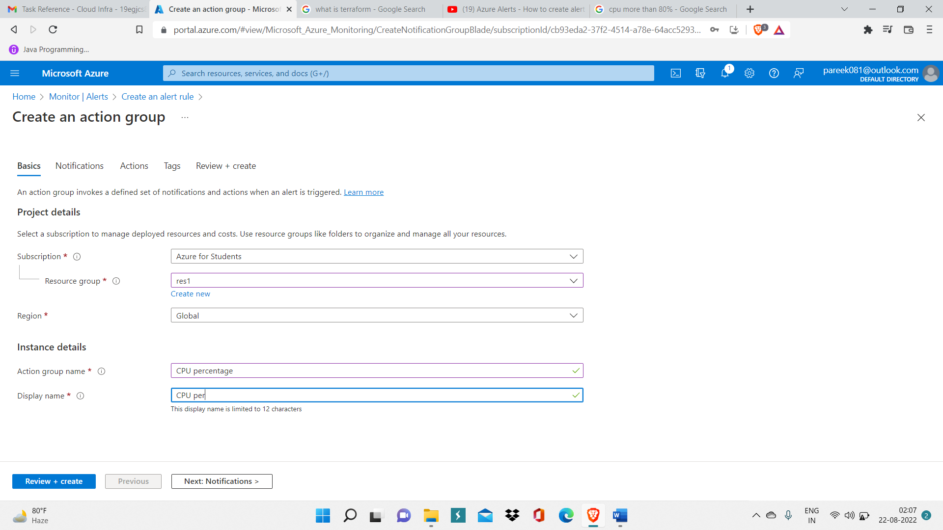

Step 7: Now inside notification select Email as notification type and specify email Id in which alert will be send and click on Ok and then click on Create for creating action group.

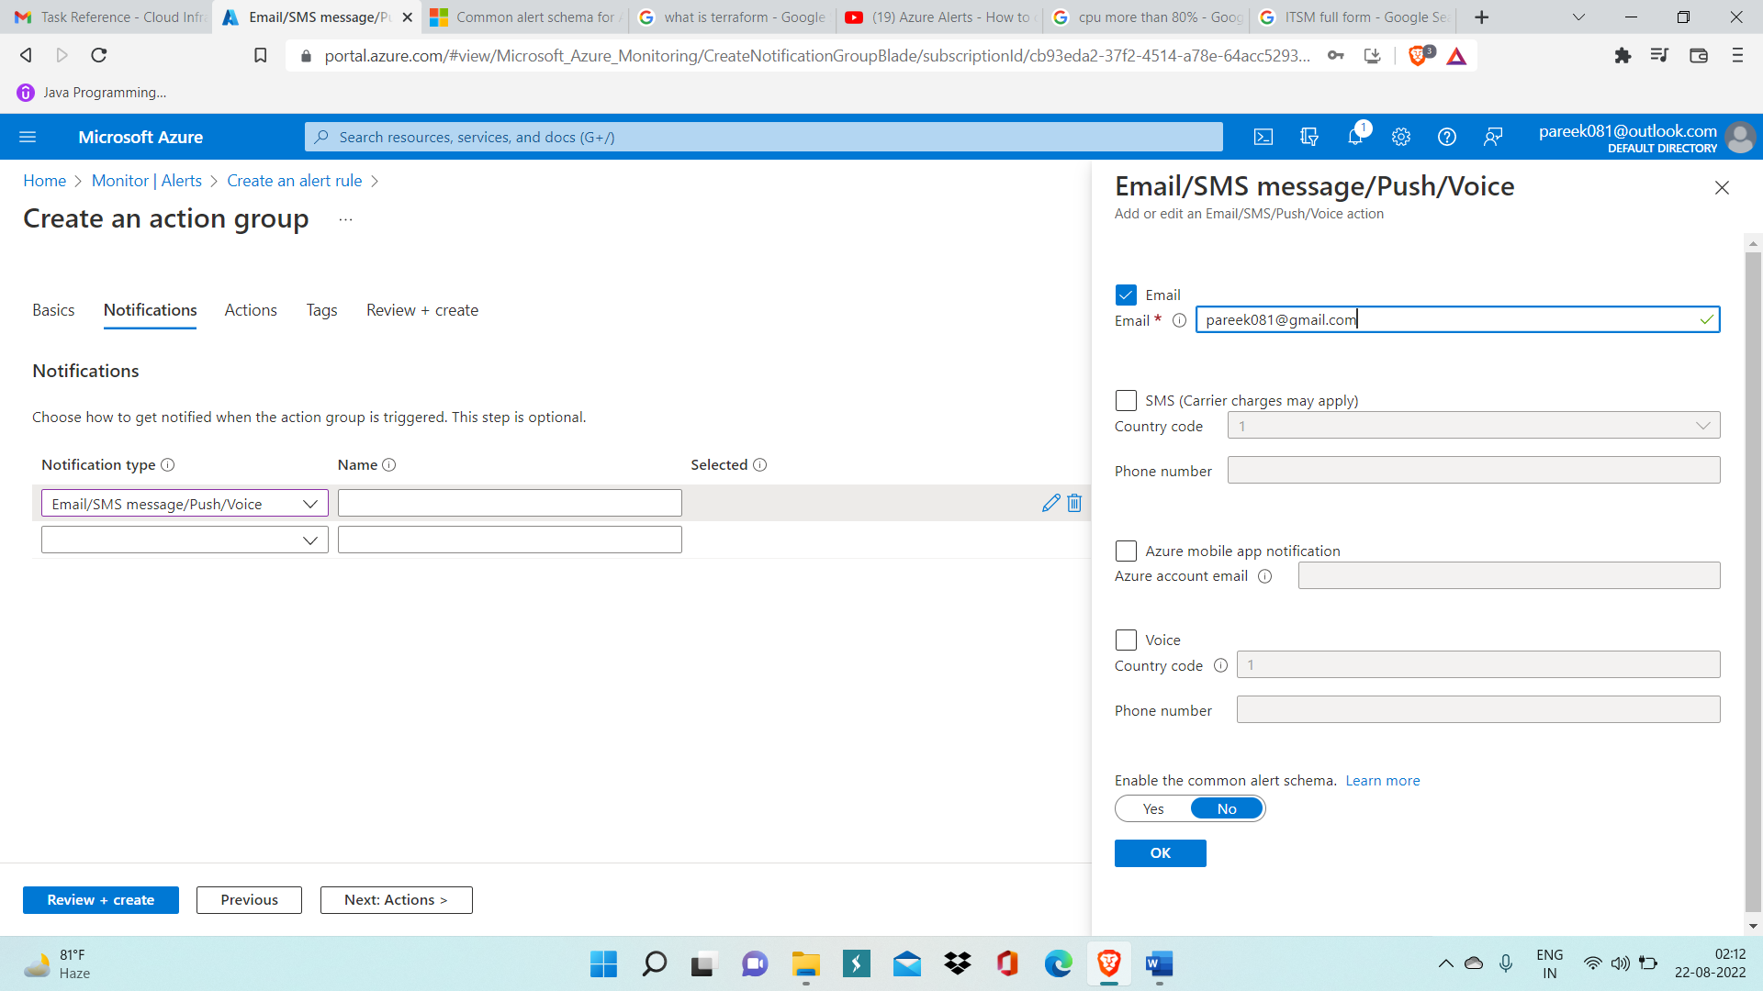

Step 8: Hence, alert rule for CPU percentage has been created successfully and you can now keep track of total alert and other related work inside Alert overview page.

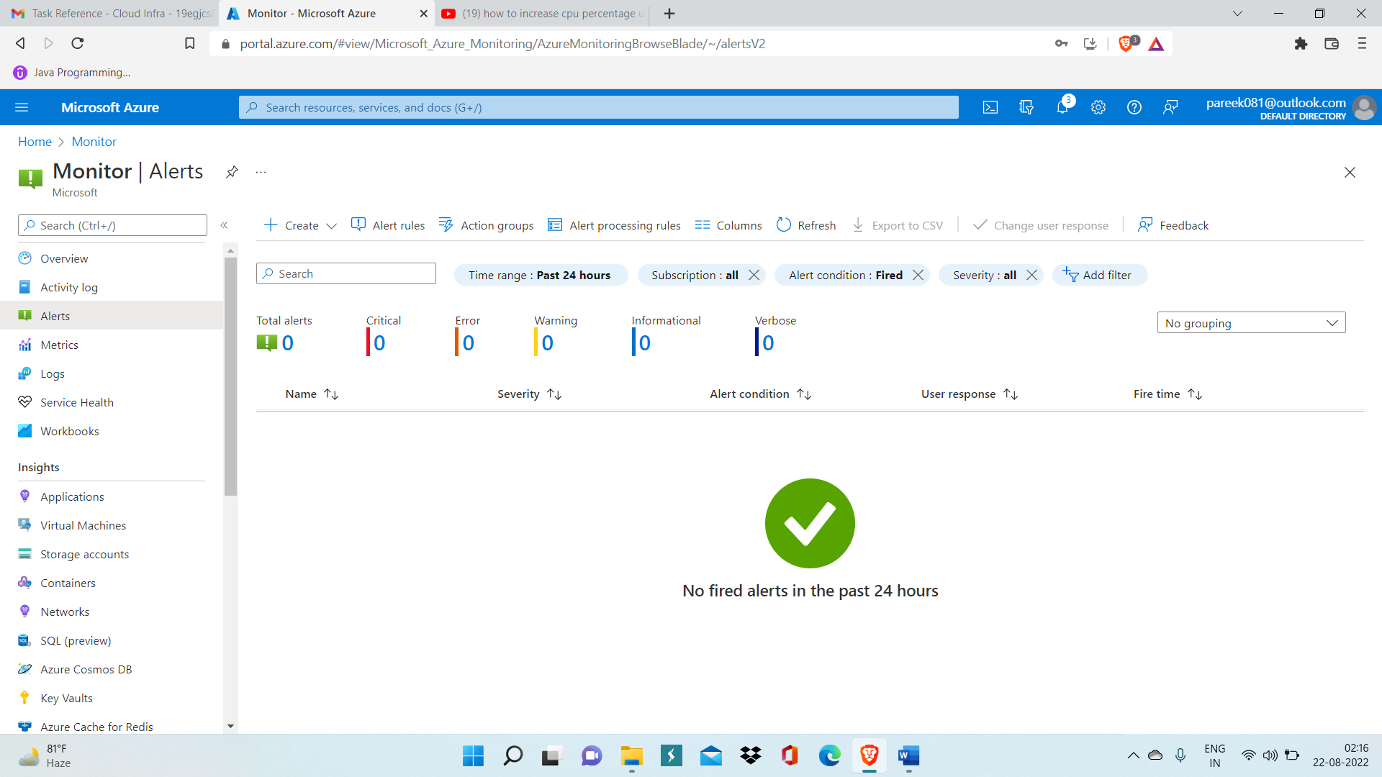

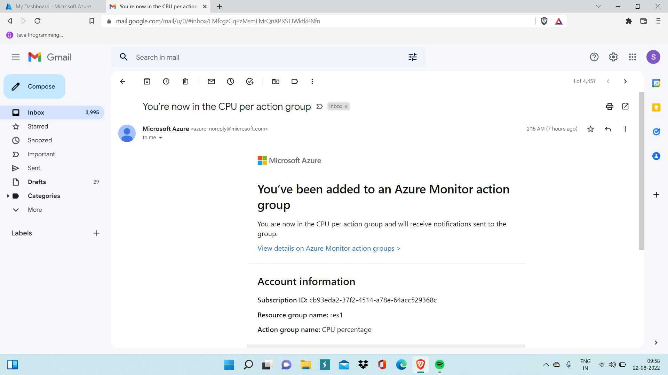

This mail received on email id we entered for alert rule verifies that alert rule is properly created.